# Gastroenterology Referral Form

## Patient details:

First name: Surname:

Address:

State: Postcode:

Phone: DOB:

## Request:

O Consultation O Colonoscopy O Gastroscopy

## Current medications and alerts:



### MBBS BMedSci FRACP

Provider No. 264383UF

O Diabetes - on tablets or insulin (please circle)

O Anticoagulants - warfarin, Plavix, Xarelto, Eliquis, other O Renal impairment

## Clinical details:

**Referring Doctor’s details:**

Doctor’s name: Address:

Phone: Provider number:

Signature: Date:

#### Phone: 07 3193 0877 Fax: 07 3319 6466 Email[: reception@drjasonhuang.com.au](mailto:reception@drjasonhuang.com.au) [www.drjasonhuang.com.au](http://www.drjasonhuang.com.au/)

##### Locations:

St Andrew’s War Memorial Hospital Sessional Suites, Level 4

457 Wickham Terrace

Brisbane QLD 4001

Holy Spirit Northside Private Hospital Arnold Janssen Building, Suite 15, Level 1 627 Rode Road

Chermside QLD 4032

**Correspondence:** PO Box 206, Ashgrove QLD 4060

# For all appointments please call: 07 3193 0877

##### Locations:

St Andrew’s War Memorial Hospital Sessional Suites, Level 4, Yellow lifts, 457 Wickham Terrace

Brisbane QLD 4001

Holy Spirit Northside Private Hospital Arnold Janssen Building, Suite 15, Level 1 627 Rode Road

Chermside QLD 4032

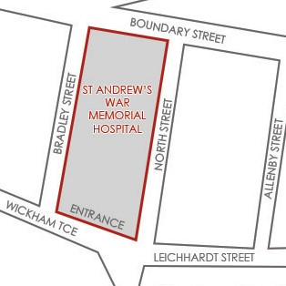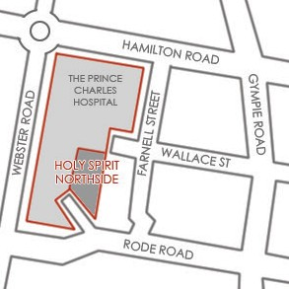

**Notes:**